SDP, MIP, CuttingSand Supporting Document

Main Idea:
Recreate the game mechanic of Sand Drop Puzzle with the addition of dropping sand whenever the player clears the top and sides of a certain color.

References:
- Regular Gameplay Mechanic
- Bubble Shooter Mechanic
- Google Play
- App Store

Objective:
Players must fill the buckets with the correct color of the sand without filling up the conveyor belt below.

Visual:
- 2D
- 2D Perspective
Tutorial:
- Hand makes a tapping motion over the screen to indicate that the player must tap to clear the colors.

Core Gameplay:
- The player is presented with a board with an image on the top and buckets + a conveyor belt at the bottom
- The objective of the game is to clear the board by having the sand from the image fill into the correct spots

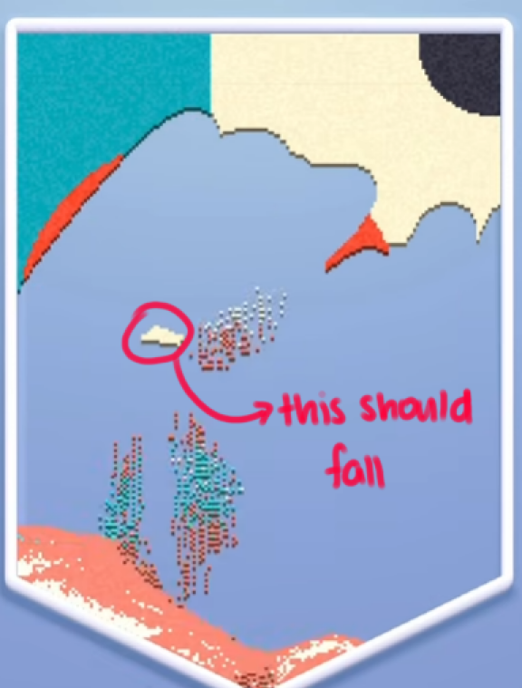
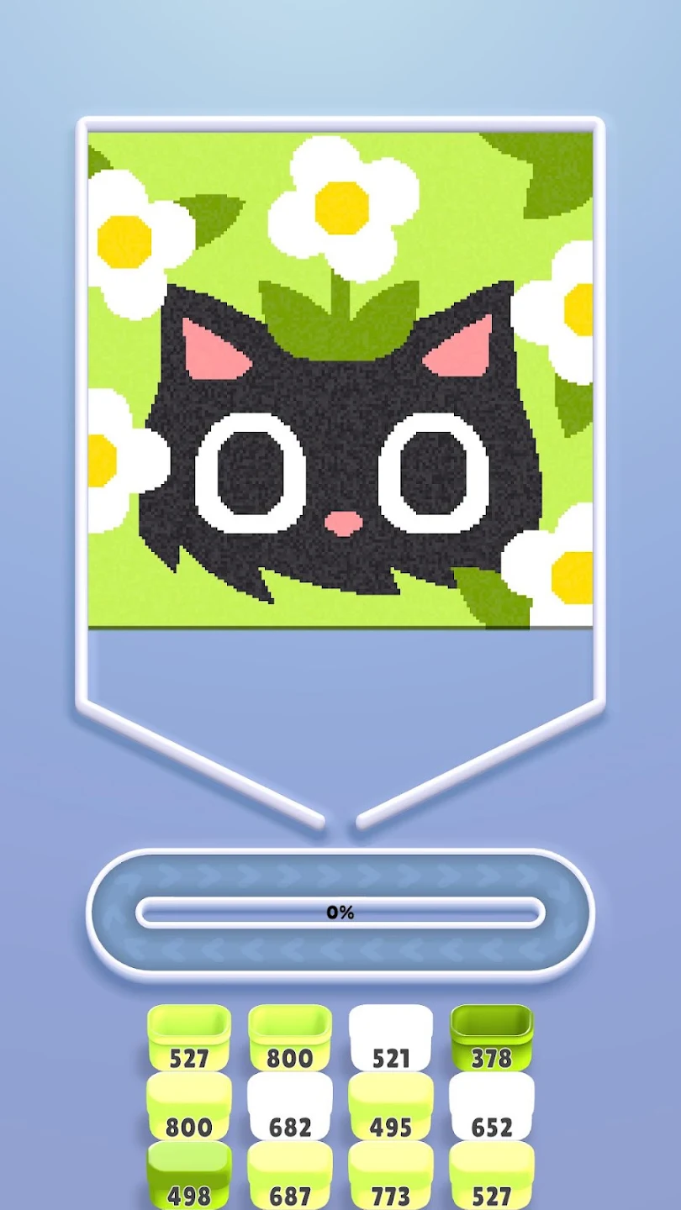
Starting Board State (left), New mechanic sample condition (right)
- Players can clear a color/chunk/section of the puzzle by tapping their finger on a specific spot
  - Only sand with the same color fall in a clump together
- The sand then falls onto the conveyor belt and will distribute in the corresponding bucket colors if they are on the lower half of the conveyor belt.
  - Whenever sand falls down to the conveyor belt, the percentage in the middle adjusts the number to indicate how filled it is
  - Colors can overlap in the conveyor belt but will be distributed properly in the corresponding buckets once they reach the lower half
- Only the buckets at the very front of the columns count when distributing colors
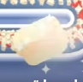
  - A bucket’s starting number will always be 800
  - Once a bucket’s number reaches 0, it will have a small jump and sparkle animation as the lid closes and it flies off to the right side and then the next bucket in line will move up (For Art: please take note of the animation)
- If the tapped color is in the middle and cannot reach the conveyor belt, the sand animation goes through but it remains inside its enclosed space and only falls down once there is a clear pathway
- ADDITIONAL MECHANIC REQUESTED BY CLIENT: When a sand clump is free on all sides, it should fall automatically into the conveyor belt to ensure that there are no floating pieces. (For Art: Please show this in the mockup for clarity)
- HINT: When the player is idle for 10 seconds show the tapping hand again

Fail State:
- Once the conveyor belt reaches 100% and the buckets at the bottom do not match to any of the colors of the buckets in the front row. (Both conditions must be met for a fail state.)

Variations:
- 5 clicks
- 10 clicks
- 90 seconds

Design
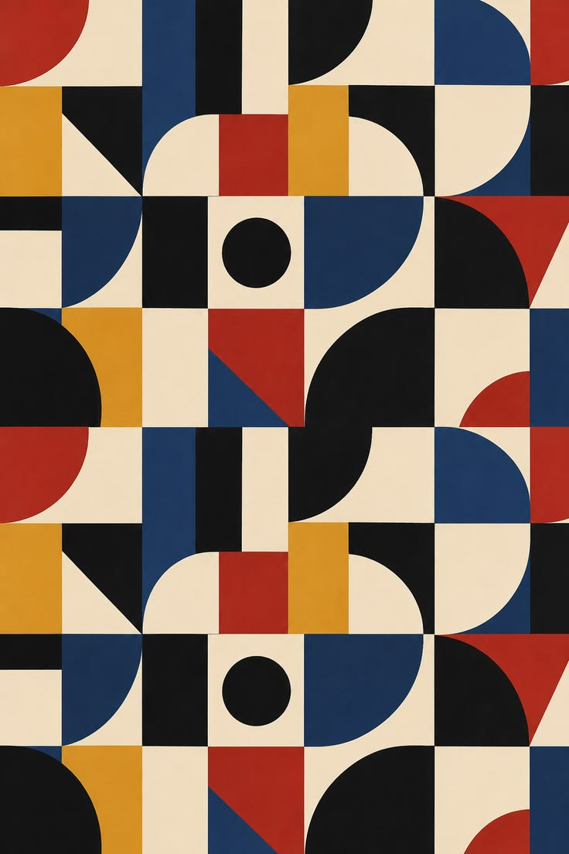
Note: This image is provided by the client. Please make sure that when doing the mockup a sand grain texture is added to ensure consistency with the game’s style.

